**Apollo Federation (Technical)**

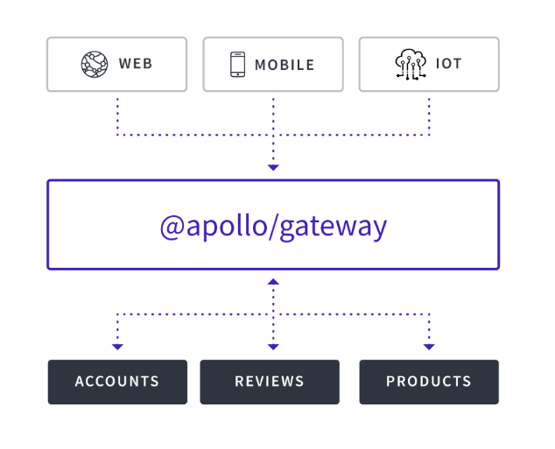

ERD

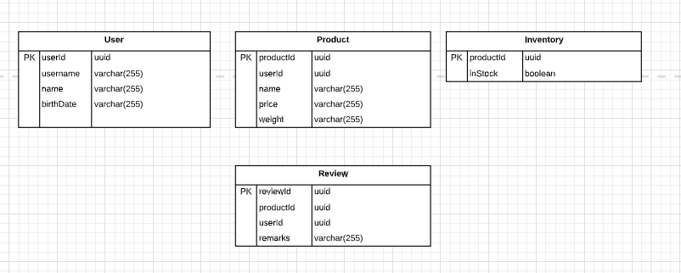

Core Concept:

1. Type Reference

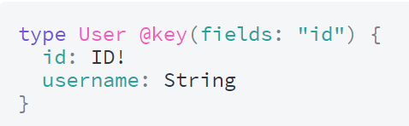

1. Type Extension

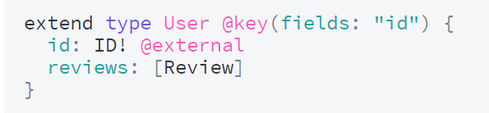

Schema

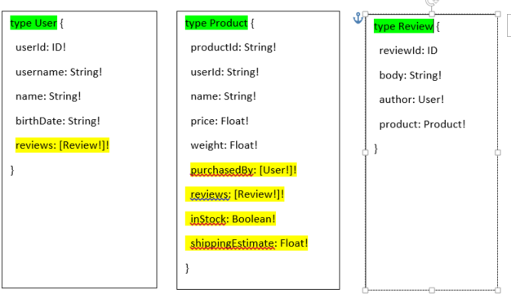

Consider the **reviews** field of the **User type** in the above schema. Even though this field is a member of the **User type**, a list of **Reviews** should nevertheless be populated by the **Reviews** service, not the **User**service.

By defining the **reviews** field in the **User**service instead:

* The service that defines the field is also the service that knows how to populate the field. The user’s service might not even have access to the back-end data store that contains review data.
* The team that manages review data can contain all review-related logic in a single service that they own unilaterally.

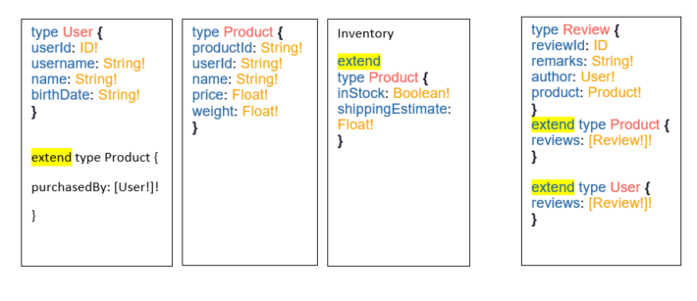

The difference is that now, each service defines the types and fields that it is capable of (and should be responsible for) populating from its back-end data store.